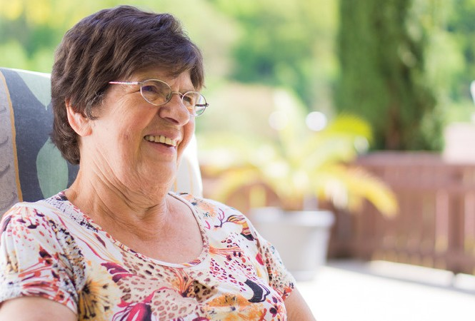

Alone and A g i n g

I N T R O D U C T I O N

Nearly one-third of all seniors live by themselves, according to the
U.S. Census Bureau. That’s close to 13.8 million seniors aging alone.
Senior isolation is both common
and dangerous — and while living alone doesn’t inevitably lead to
Senior loneliness, the two often go hand in hand.

THE EFFECTS
Loneliness leads to stress
Increase in unhealthy habits like smoking.
Increases the risk of Alzheimer
Isolation leads to instances of
Abuse
Seniors become negative and often assume the worst.

S O M E F A C T S: W H Y S E N I O R S A R E A G I N G
A L O N E

Change in family dynamics
Change in neighborhood dynamics
Transportation challenge LGBTQ seniors are likely to be isolated
SOLUTIONS
Reaching out to them
makes a huge difference volunteering in centers and homes goes a long
way in helping them Government doing its part to fund programs for
seniors
The use of technology
ACTION
The aged are entitled to freedoms and rights
just like any other individuals. Injustices against the old should be dealt with and people work towards building stronger
human connections. Families should depict togetherness and take care of each other
regardless of their situations.

